Our Session Fees

Sessions and Fees
Payments can be finalised by either cash or bank transfer; Bank account details can be found on your invoice.

Equine-Assisted Therapy
Adults are $190 ph.
Child/Teen $150 ph.

Room Based Therapy
Adults are $190 ph.
Child/Teen are $150 ph.
​
NDIS Participants
We can provide services to NDIS participants that are Self-Managed
or Plan Managed.
​
Medicare
We do not provide mental health services funded through Medicare.

Retreats
COMING SOON
​
Equine Assisted Learning
COMING SOON

Let's Connect

Contact

Address
86 Camerons Road,
Underwood TAS 7268

Phone
0413 781 727

Email
parihan@brumbyeat.com

website
www.brumbyeat.com.au

Social Media

We Support the NDIS
Fully insured with Affinity Equine Insurance
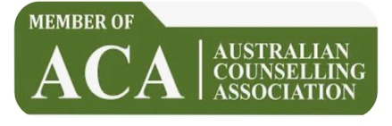

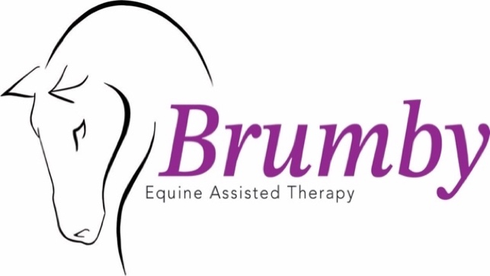

“Our approach is designed to honour your spiritual, mental, and physical growth as you embark on your journey of self-discovery.”

Brumby Equine Assisted Therapy would like to respectfully acknowledge the traditional custodians on the land that which we live on and pay respect to Australian’s First Peoples and to the Elders past, present, and emerging.

© 2023 Brumby EAT
What is Equine-Assisted Mental Health Therapy? Equine Assisted Mental Health (EAMH) therapy is an emerging and effective form of therapeutic intervention that involves engaging with horses in a nature-based setting through experiential activities. This unique approach is facilitated by qualified Equine Assisted Mental Health practitioner, who are not only trained in mental health services but also possess the necessary skills in equine handling. These professionals apply a wide range of psychological and human developmental principles and methods to address the individual treatment needs and goals of each client. At Brumby Equine Assisted Therapy, we also incorporate the model, methods, and principles of Equine Assisted Therapy Australia (EATA) to ensure the delivery of competent and compassionate services.

Our Services
At Brumby Equine-Assisted Therapy, we offer person-centred, strengths-based and trauma informed counselling services aimed at helping individuals rebuild resilience and find enjoyment in life. We apply a wide range of psychological and human developmental principles and methods to address the individual treatment needs and goals of each client. We also incorporate the model, methods, and principles of Equine Assisted Therapy Australia (EATA) to ensure the delivery of competent and compassionate services.
Our approach incorporates body-oriented strategies, such as breathwork and resource exercises, with the primary goal of bringing participants into the present moment and fostering awareness of their experiences.
We provide individual therapy sessions for children, adolescents, and adults facing mental health challenges. These sessions involve supported experiential learning and activities in a therapeutic context, where horses play an integral role.
Our therapeutic treatments focus on cultivating safe relationships, attunement, emotional regulation, emotional knowledge, psychoeducation, and developing competencies in boundaries and non-verbal communication.
Through our services, we aim to assist you in recognising and addressing emotional blocks, connecting with your body's cues, and gaining a deeper understanding of yourself. Our goal is to support your journey towards personal growth, healing, and improved well-being.

How can Equine-Assisted Mental Health Therapy help me?
Our sessions are carefully designed to cater to each individual's unique therapeutic goals. By working with our horses, you will find a safe and non-judgmental space to share your story. Equine-assisted mental health therapy offers numerous benefits, including:

- Building self-esteem and confidence
- Developing effective communication skills
- Learning healthy coping strategies
- Nurturing compassion, empathy, and self-acceptance
- Cultivating a sense of self-empowerment
- Enhancing self-awareness
- Encouraging personal growth
- Equipping you with the skills needed for healthy relationships

There is growing evidence that support the effectiveness of Equine-assisted mental health therapy in treating a wide range of personal and psychological challenges, including:

  - Depression and anxiety
  - Post-Traumatic Stress Disorder (PTSD)
  - Eating disorder
  - Autism and Asperger’s
  - ADD and ADHD
  - Substance abuse
  - Relationship difficulties
  - Stress
  - Bullying – both for the committer and he victim
  - Attachment issues, including adoption adjustment
  - Low self-esteem
  - Negative behavioural challenge

Our aim is to provide a therapeutic experience that supports your healing journey and helps you overcome these challenges. Our horses play a crucial role in facilitating this process, offering a unique and powerful form of therapy.
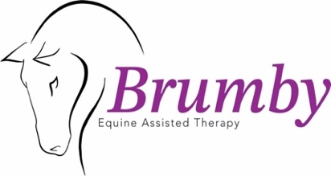
© 2023 Brumby EAT

